Database updated

--sprint3

**1. upload**

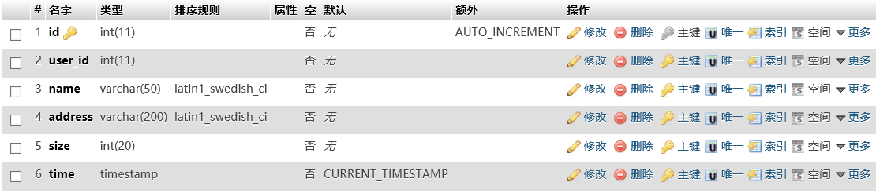

**2. recycle_bin**

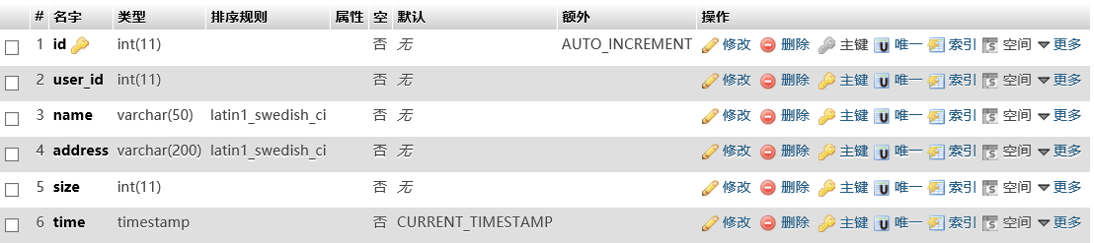

**3.user_information**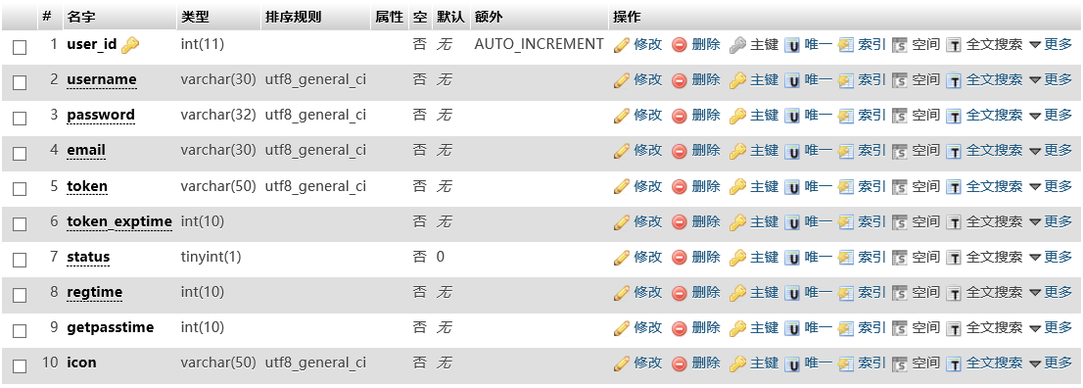

**4. user_details**

